Installing the AdventureWorks Database

- Go to https://docs.microsoft.com/en-us/sql/samples/adventureworks-install-configure?view=sql-server-2016
- Click on AdventureWorks2016.bak under OLTP downloads.
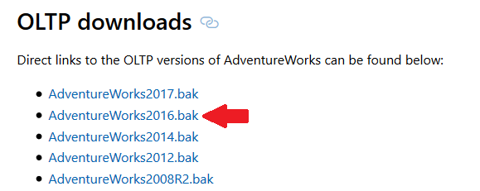
C:\Program Files\Microsoft SQL Server\MSSQL13.MSSQLSERVER\MSSQL\Backup
Note that your exact path may differ slightly based on where your program files are located.
- Copy downloaded .bak (stands for “backup file”) in the following location
C:\Program Files\Microsoft SQL Server\MSSQL13.MSSQLSERVER\MSSQL\Backup
Note that your exact path may differ slightly based on where your program files are located.
- Open SQL Server Management Studio. If using a virtual machine, it will be located on your Desktop. If you have difficulty finding where it is installed (and not using the virtual machine), try looking under All Programs or using the Search tool.
- Right-click Databases and select Restore Database
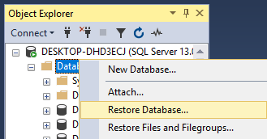
- Select Device and click the ellipses (...)
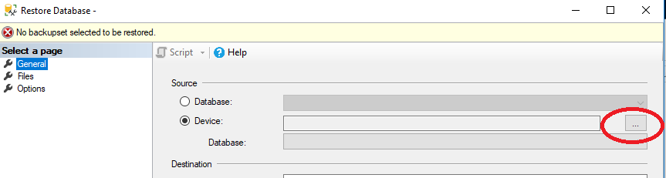

- In the dialog Select backup devices, click Add, navigate to the database backup in the file system (the file you just downloaded), and select the backup file. Click OK.
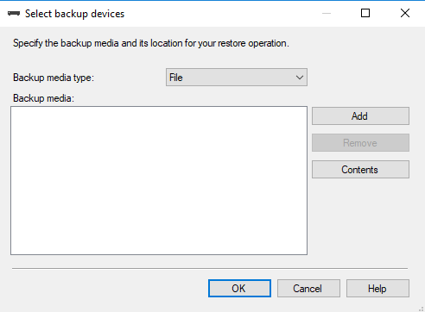
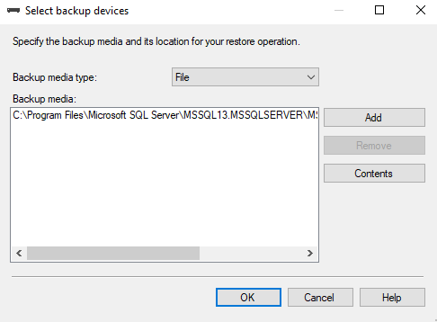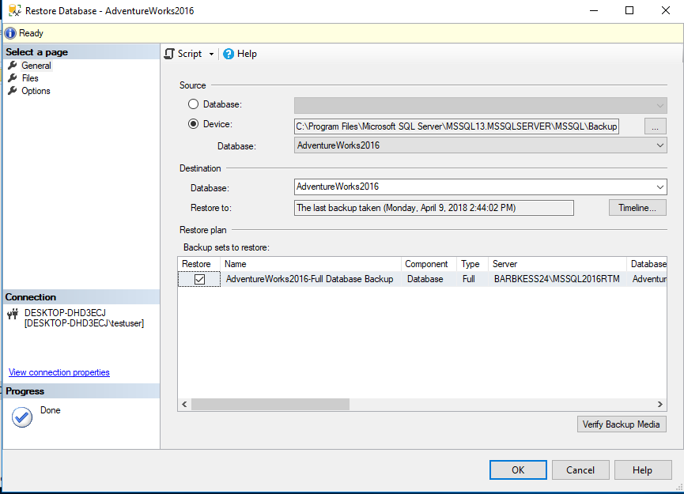

- Click OK. This will initiate the database restore. After it completes, you will have the AdventureWorks database installed on your SQL Server instance.
